Seniors SIG Notes – June 2012.

General discussion plus Q & A
Today’s Presentation:
CONNECTING COMPUTERS TO NETWORKS
 | ALL WIRED |  |  |  | ALL WIRELESS
Connecting one computer with Local Area Network LAN but no internet service
 | Cables to keyboard, mouse, printer, etc. |  |  |  | Wireless keyboard, mouse, printer using Bluetooth or Wi-Fi
 | Connections: PS2 (old) USB3 (new) |  |  |  | 2.4GHz or 5GHz to about 30m
Typical activities include: Creating office documents, photo enhancing, playing computer games, etc.
Connecting two or more computers with Local Area Network LAN but no internet service
 | As above: plus Ethernet card and cables (old) or USB3 cables (new) to each computer |  |  |  | As above
Additional activities may include: File & printer sharing
Connecting to the internet
 | Using a cable modem/router connected to a dial-up phone line, ADSL broadband or fibre optical cable |  |  |  | Using a Wi-Fi hotspot or mobile/wireless broadband with Subscriber Identity Module (SIM card)
 | Transfer speeds: 56 Kb/s to 200 Mb/s |  |  |  | Broadband transfer speeds: 2Mb/s to 40 Mb/s
 | Protocols: http (web) tcp/ip (email) ethernet (file transfer) |  |  |  | Wireless Application Protocols (WAP): GSM (2G) UMTS (3G)
 |  |  |  |  | Wireless frequencies: 850 MHz, 900 MHz, plus 2100 MHz (Telstra, Optus, Vodaphone, 3)
Additional activities may include: Web browsing, emailing, online shopping – banking - games, video conferencing, downloading & watching movies, remote backups, etc.
 | A mix of wired and |  | wireless is another option
Jl Jun 2012
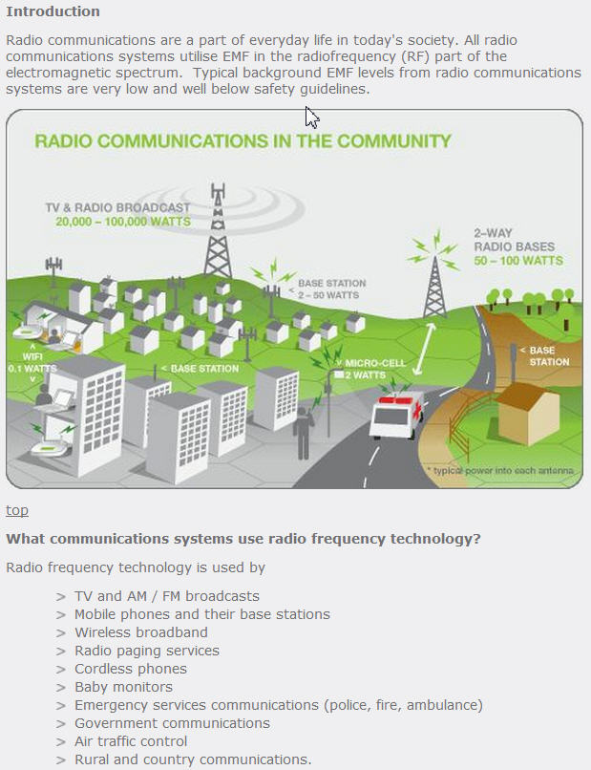
Electromagnetic Fields Explained: http://www.emfexplained.info/
YouCompare http://broadbandguide.com.au/
Compare Speeds SMH: http://broadband.smh.com.au/Broadband
Free Hotspots (NSW) http://www.freewifi.com.au/region_nsw.php

Bluetooth vs Wifi http://www.diffen.com/difference/Bluetooth_vs_Wifi

3G vs 4G http://www.diffen.com/difference/3G_vs_4G

Wireless Standards with Link Rate:
IEEE 802.11n (up to 300Mbps) for 2.4GHz and 5GHz*
IEEE 802.11g (up to 54Mbps*)
IEEE 802.11a (up to 54Mbps*)
IEEE 802.11b (up to 11Mbps*)

Wireless Operating Spectrum:
Simultaneous Dual-Band 2.4GHz and 5GHz
While both types may operate on the same network, they use different transmission frequencies and TCP/IP domains to access them

Mobile Phone Frequencies
Australian 3G bands:
850MHz (Telstra, Vodafone) – Exclusive 3G band
900MHz (Optus, Vodafone) – Re-uses the 2G 900 band for 3G in rural areas
2100MHz (Telstra, Optus, Vodafone, 3 Mobile) – Exclusive 3G band

Electromagnetic Fields Explained: http://www.emfexplained.info/

